**EXPERIMENT NO:-3**

**AIM:**

To familiarize DDL Commands- ALTER,DROP,TRUNCATE,RENAME

**PROCEDURE:**

1. Create a table emp with attributes empno number(4)as primary key, ename

char(10),hiredate, salary,commission and insert the following 5 rows of data

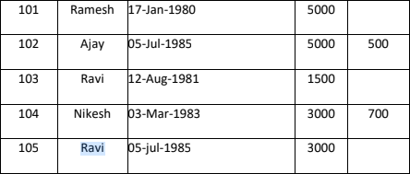

CREATE DATABASE EMPLOYEE;

USE EMPLOYEE;

CREATE TABLE EMPLOY(EMPNO INT PRIMARY KEY,ENAME VARCHAR(20),HIREDATE DATE,SALARY FLOAT,COMMISSION FLOAT);

INSERT INTO EMPLOY VALUES(101,"RAMESH",'1980-01-17','5000',NULL),(102,"AJAY",'1985-07-05','5000','500'),(103,"RAVI",'1981-08-12','1500',NULL),(104,"NIKESH",'1983-03-03','3000','700'),(105,"RAVI",'1985-06-05','3000',NULL);

SELECT *FROM EMPLOY;

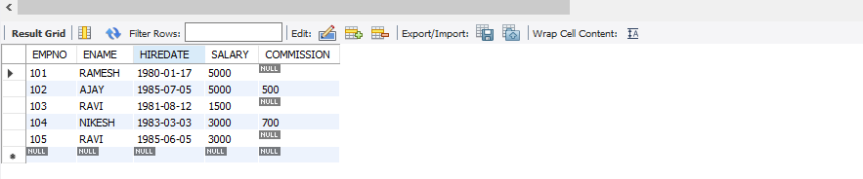

1. Add check constraint (Salary >=5000)

ALTER TABLE EMPLOY MODIFY SALARY FLOAT CHECK (SALARY>=1500);

1. Add Check Constraint (length(empno<=3))

ALTER TABLE EMPLOY MODIFY EMPNO INT CHECK(LENGTH(EMPNO)<=3);

4.Modifying the structure of tables

* 1. Add new columns: sal number(7,2)
  2. Alter table emp add column sal_num float(7,2);

ALTER TABLE EMPLOY ADD SAL NUMERIC;

SELECT *FROM EMPLOY;

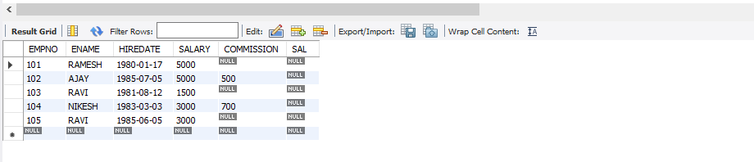

ALTER TABLE EMPLOY DROP COLUMN SAL;

SELECT *FROM EMPLOY;

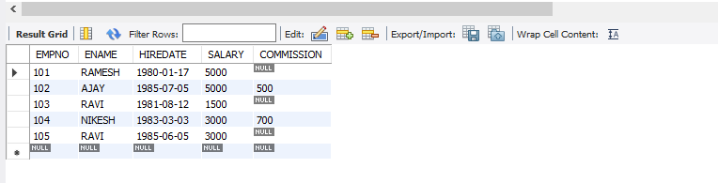

ALTER TABLE EMPLOY MODIFY ENAME VARCHAR(15);

ALTER TABLE EMPLOY RENAME TO EMPLOY1;

SELECT * FROM EMPLOY1;

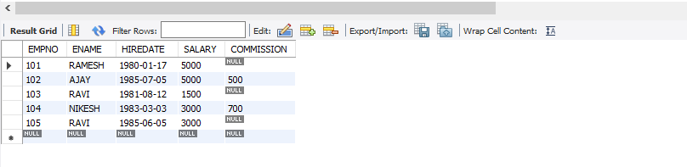

SHOW TABLES;

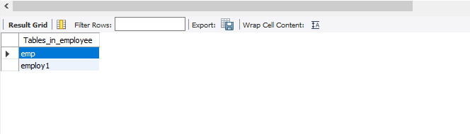

TRUNCATE TABLE EMPLOY1;

SELECT * FROM EMPLOY1;

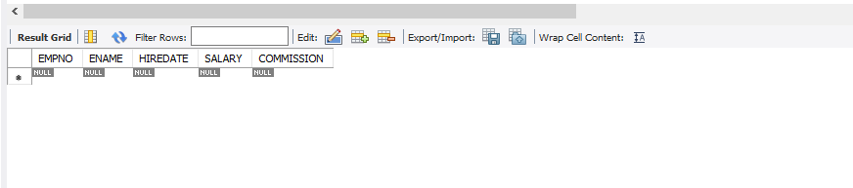

DROP TABLE EMPLOY1;

SHOW TABLES;

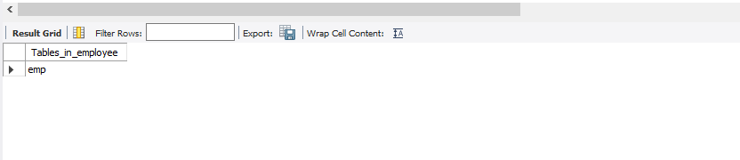

SHOW DATABASES;

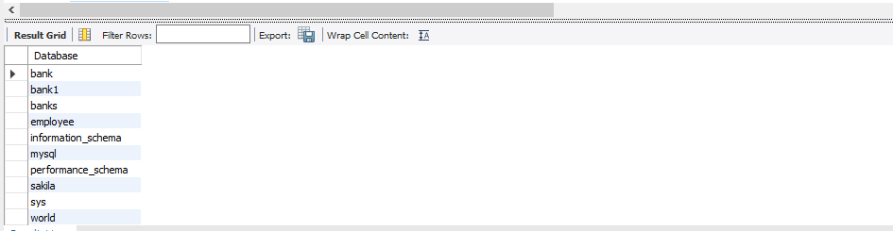

DROP DATABASE EMPLOYEE;

SHOW DATABASES;

